**Name**: S.Vaneeshwari

**College code**: 9530

**College name**: St. Mother Theresa Engineering College

**Team ID**:

**Naan Mudhalvan ID**: au953021104054

**Project Name**: Big Data Analysis with IBM cloud databases

**INTRODUCTION:**

Climate change is a pressing global issue, and big data analysis plays a crucial role in understanding its complexities. Big data encompasses vast sets of climate-related information, such as temperature records, satellite imagery, and greenhouse gas emissions data. By analyzing this data, scientists can identify trends, model future climate scenarios, and make informed policy decisions.

Big data analytics enables researchers to:

1. Detect patterns and trends

2. Model climate scenarios

3. Monitor environmental changes

4. Assess climate impacts

5. Track greenhouse gas emissions

In summary, big data analysis is a powerful tool in our efforts to address and mitigate the impacts of climate change by providing valuable insights and supporting informed decision-making.

**PROBLEM SOLUTION:**

To find a solution to your problem statement, you can use IBM Cloud Databases to store and manage vast datasets. You can then use the built-in analytics tools to uncover hidden insights from the data. Once you have identified the insights, you can visualize them using the built-in visualization tools. This will help you derive valuable business intelligence from the data and make informed decisions. Using big data to address climate change involves collecting, analyzing, and applying large volumes of data to develop informed strategies and solutions. Here's how it can be done:

1. Data Collection: Collect climate-related data from various sources, such as satellites, weather stations, IoT sensors, and social media. Include data on temperature, carbon emissions, air quality, deforestation, and more.

2. Data Analysis: Employ machine learning algorithms to process and analyze the data to identify trends, correlations, and anomalies. Predict future climate patterns, extreme weather events, and their impacts.

3. Energy Efficiency: Use data to optimize energy consumption in industries and building. Implement smart grids and sensors to monitor and control energy usage in real-time.

4. Carbon Footprint Reduction: Track carbon emissions across industries and transportation. Identify areas for emission reductions and prioritize actions based on data insights.

5. Renewable Energy: Analyze weather and energy production data to optimize renewable energy sources like solar and wind. Predict energy generation and demand to ensure a stable grid.

6. Climate Resilience: Use data to assess vulnerabilities and develop adaptive strategies for communities and infrastructure. Monitor changes in sea levels, temperature, and extreme events to enhance preparedness.

7. Agriculture and Land Use: Optimize farming practices using data on weather, soil conditions, and crop performance. Promote reforestation and sustainable land management based on data-driven insights.

8. Behavioral Change: Leverage data to influence consumer behavior through personalized recommendations and incentives. Encourage eco-friendly choices in transportation, consumption, and energy use.

9. Policy and Advocacy: Provide policymakers with data-driven evidence to support climate policies. Advocate for informed decisions and international cooperation based on shared data.

10. Monitoring and Reporting: Continuously monitor progress toward climate goals using real-time data. Share transparent reports to hold governments and industries accountable.

Big data analytics can empower governments, businesses, and individuals to make informed decisions, reduce greenhouse gas emissions, and adapt to the changing climate. It's a powerful tool in the fight against climate change.

**METHODOLOGY:**

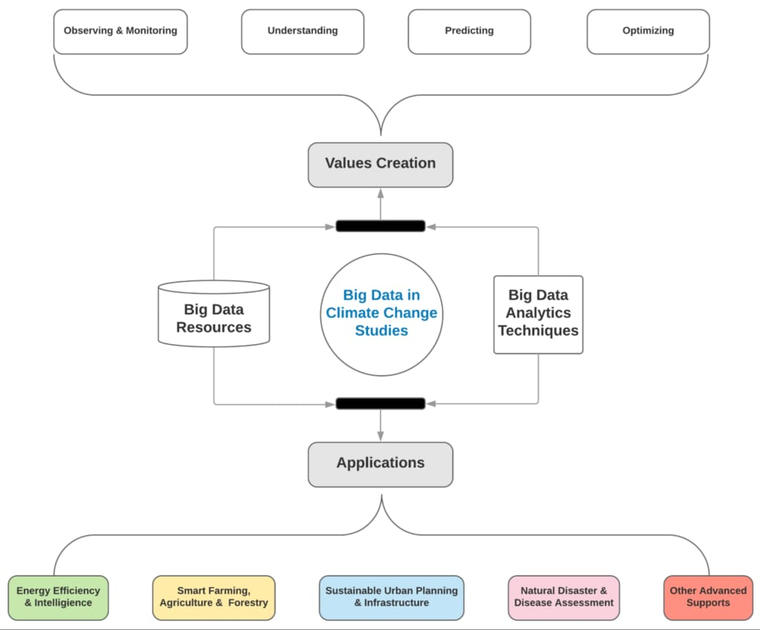

**GITHUB LINK:**